**Final Project Job Board**

**Full Stack Web Development Internship Program By Edureka!**

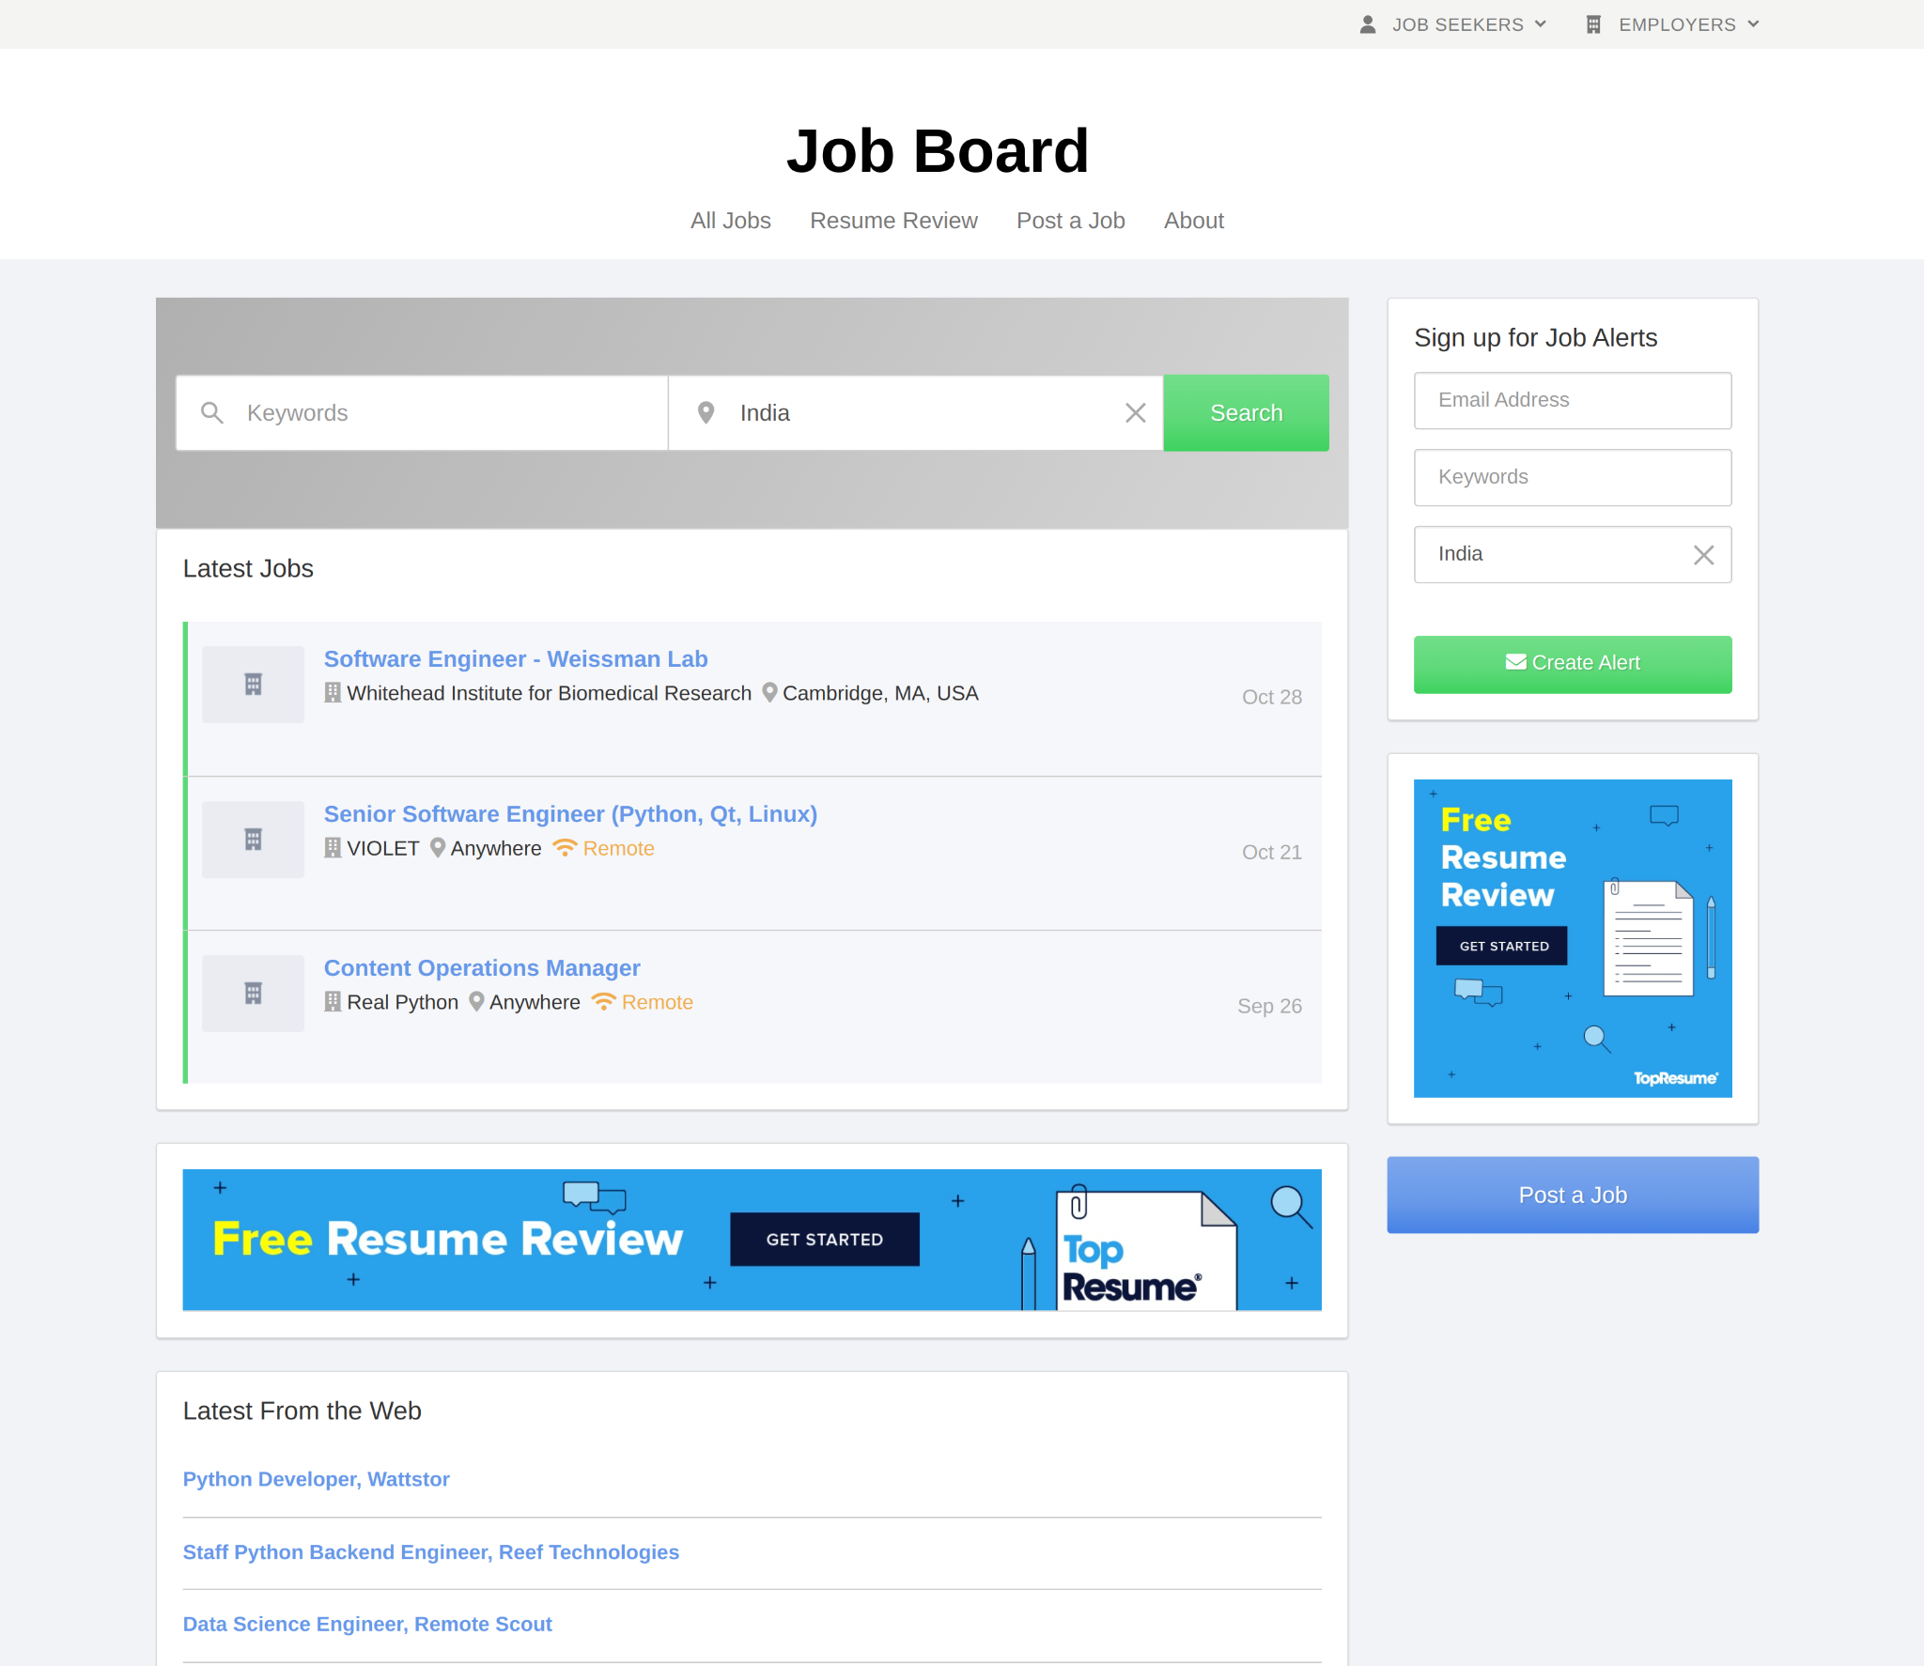

**Project Name: Job Board**

**By: Ashish Negi**

**Under Guidance: AAKASH HANDA**

**Batch: 67**

**Presents By: Edureka!**

**Overview**

**Job Board is an online job portal platform where our job seekers can get their desired jobs according to their interest, qualifications, skills set on computer science technology only. The Job Board is also for those Employer who wants the best employee for their company and orgnigations here they can find employe according there project and company requirement.**

**Goals**

* **Login Page**
* **Job Seekers Profile And Account Dashboard**
* **Employer Profile And Account Dashboard**
* **Free Resume Review By Mail**
* **Sign up for Job Alerts, news letters, promotions and events**
* **Job Alert Notifications for job seekers**
* **Apply Alert Notifications for employer**
* **Blog (Computer Science Technology Articles by job board)**

**Technologies used in Job Board**

**Front-End: HTML5, CSS3, Bootstrap 5, JavaScript Es5/Es6, React**

**Back End: Node JS, Express JS, API**

**Server: AWS Amazon Web Services**

**Database: Mongodb**

**IDE And Code compilers: Visual Studio Code, GitHub, Nodejs**

**Repository Link In GitHub:** [**https://github.com/hostashish/Job-Board**](https://github.com/hostashish/Job-Board)